Implementation Standard
Clinical Assessment and Treatment (GP/NP Triage)
Purpose:
- To increase capacity
- To support proactive acute demand management in the practice
- To improve patient access to the practice team

This is not an exhaustive list but gives an idea of the sorts of things you will need to do or think about to implement GP/NP Triage into the practice.
Action Step/Task
- All staff watch GP Triage video https://vimeo.com/233244862
- Write a Project Plan on a Page to include the following consideration points
- Install the appropriate GP/NP Triage Advance Forms onto the Patient Management Systems (MedTech or Indici)
- Clinical Team orientation to the new Triage advance form.
- Conduct data collection to determine when in the day and for how long.
  - Collect over two weeks.
  - Acute demand profile across the week – where are the peaks from walk ins and phone requests.
  - Schedule GP/NP triage according to the time of day – peak/off peak.
  - Understand the reason for Walks-ins (review call system).
  - Consider Process Mapping the current acute demand patient flow (HCH team can facilitate this).
- Planning and discussion – Change team then wider Practice team
  - Based on data, decide when to do triage? How long for?
  - Service should be each day. Vary length due to demand analysis.
  - Prepare a clear guideline / script for call handlers and arrange training session.
  - Prepare a clear guideline and scripts for GPs/NPs and arrange a training session including the use of the triage advanced form.
  - Consider any adjustments to Nurse triage (GP overflow) and arrange a training session on the use of the triage advanced form.
  - Change GP/NP schedules to allocate time for triage and GP/NP book on the day appointments.
  - Consider how you want to manage email/ virtual consultations.
  - Consider fees and guidelines for staff to communicate new service fees i.e. for triage prescriptions; email consults; virtual consults.
  - Decide on a ‘go live’ date
- Communicate with Patients about this new service. Use multiple avenues (website, flyers, posters, social media).
- Actively monitor and review while continuing the service.
- Push Start on GP/NP Triage
PDCA cycle
Review/Refine/apply the continuous PDCA cycle for quality improvement
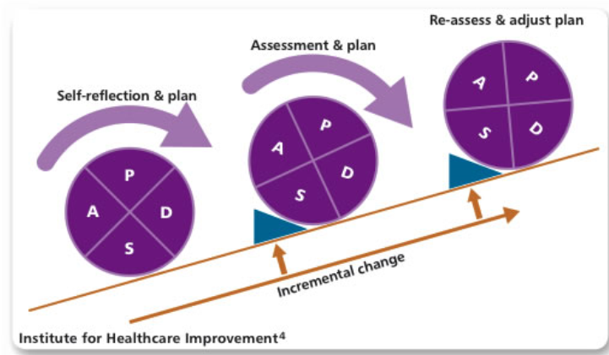

Case study: GP Triage at Gore Medical Centre
- Article: Investigating the effectiveness of virtual treatment via telephone triage in a New Zealand general practice (collabdigitalhealth.org.nz)
- Gore Medical Centre Sharing our experience: 7-4-triage-presentation-gore-medical.pptx (live.com)

